Day 15!

help me find santa please. i am getting very worried about him use this map for help.

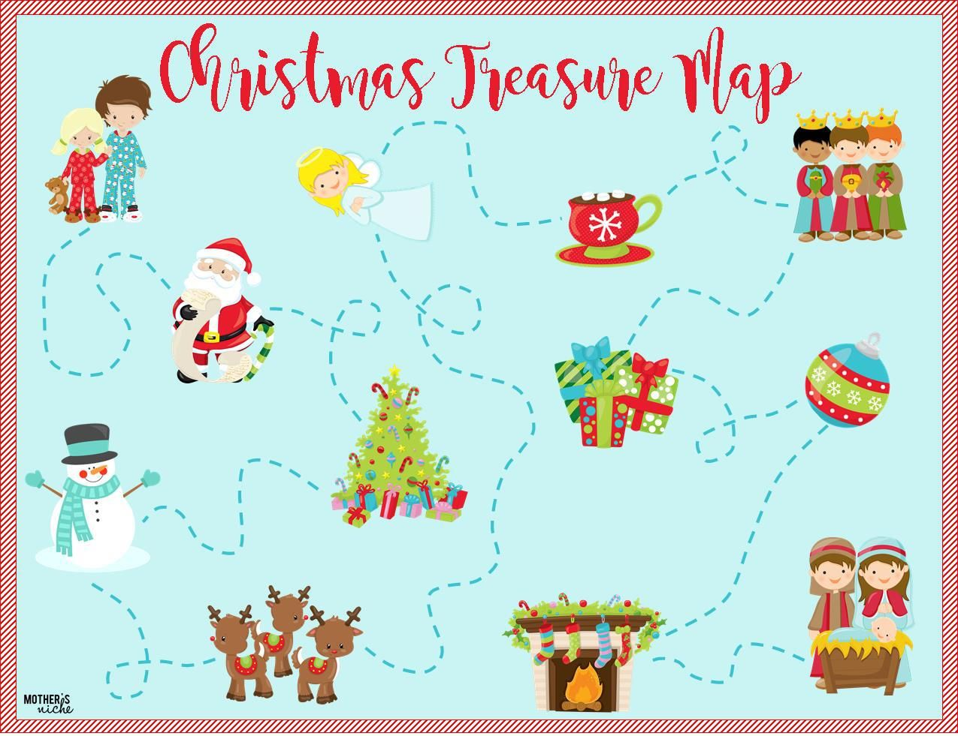 [Remix on Glitch](https://glitch.com/edit/#!/remix/glitch-hello-website)